# CREATE A SERVICE CALL - STANDARD

**CREATE AND MANAGE NAXT CUES**

## Introduction

Cues are default filters that pre-populate a list of results for you in NAXT when you select them. You can add and manage the cues that appear on your NAXT home page.

## Add a NAXT Cue

**Step 1: Navigate to your NAXT home page**

Select the ‘Home’ icon. On the left hand side of this display you should see ‘Activities’.

**Step 2: Add a Cue**

Select the ‘Add Cue’ option; the ‘Add Cue’ window will pop up.

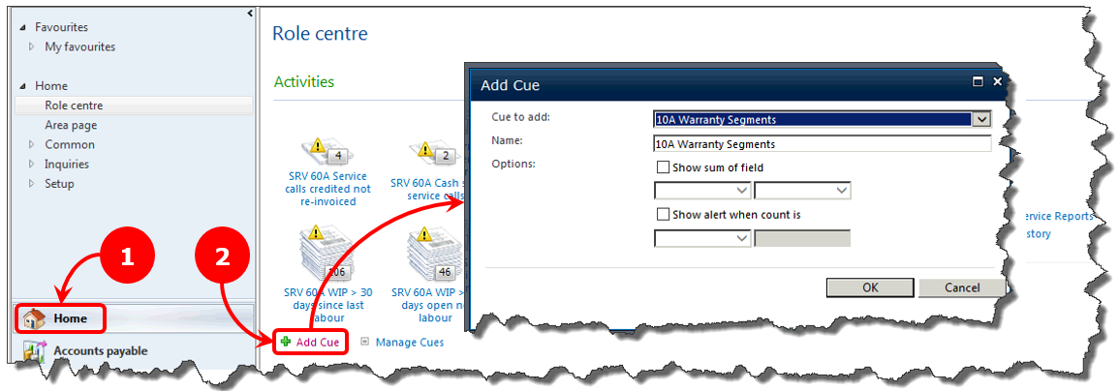

**Step 3: Filter the list of available cues**

3A: By default the ‘Cue to add’ field will be highlighted in blue and show ‘10A Warranty Segments’.

3B: Type ‘srv’ on your keyboard; the ‘Cue to add’ field should show ‘SRV – 10A Aged WIP’.

3C: ***WAIT*** for the ‘Name’ field to show ‘SRV – 10A Aged WIP’.

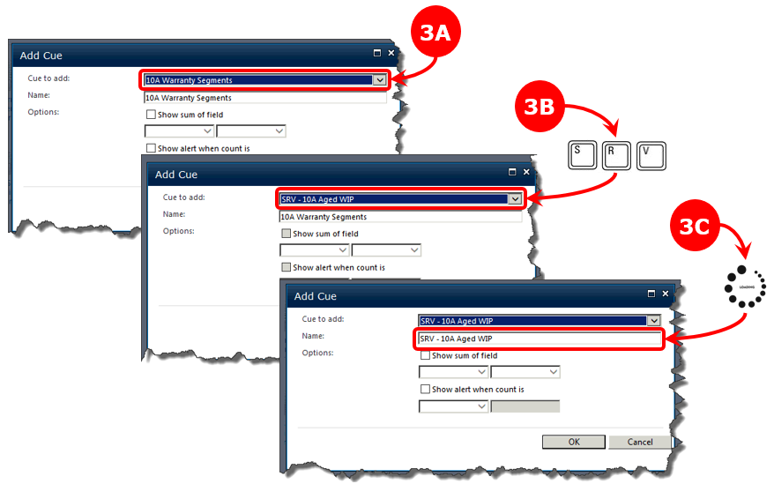

**Step 4: Locate the cue you want**

Select the drop down menu and scroll down the list of cues.

Look for ‘SRV’ then your branch number (ignore any cue that has a dash after ‘SRV‘).

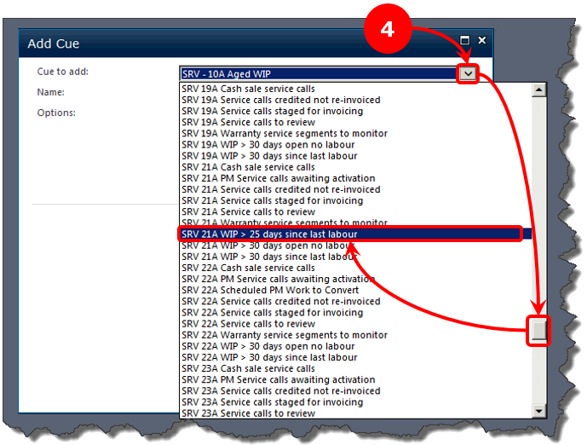

**Step 5: Select the cue you want**

5A: Select the cue you’ve located; it’ll appear in the ‘Cue to add’ field.

5B: Wait for your selected cue to appear in the ‘Name’ field.

5C: Select ‘OK’; your cue will appear on the home page at the end of any existing cues.

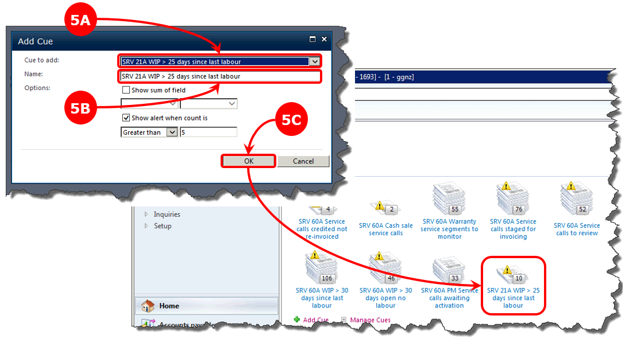

## Manage a NAXT Cue

**Step 1: Navigate to your NAXT home page**

Select the ‘Home’ icon. On the left hand side of this display you should see ‘Activities’.

**Step 2: Manage your Cues**

Select the ‘Manage Cues’ option; the ‘Manage Cues’ window will pop up.

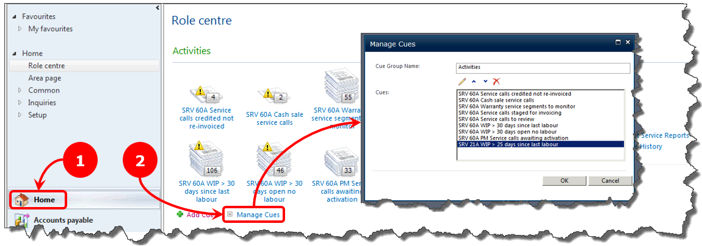

What do you want to do next?

* **I want to adjust the order of my cues; see Step 3A.**
* **I want to delete one of my cues; see Step 3B.**

**Step 3A: Adjust the order of your cues**

1: Select the cue you want to adjust.

2: Click on an up or down icon to move your cue up or down the list.

Each click will move your cue one place.

3: Select the ‘OK’ button; your selected cue will show on the home page in its new order.

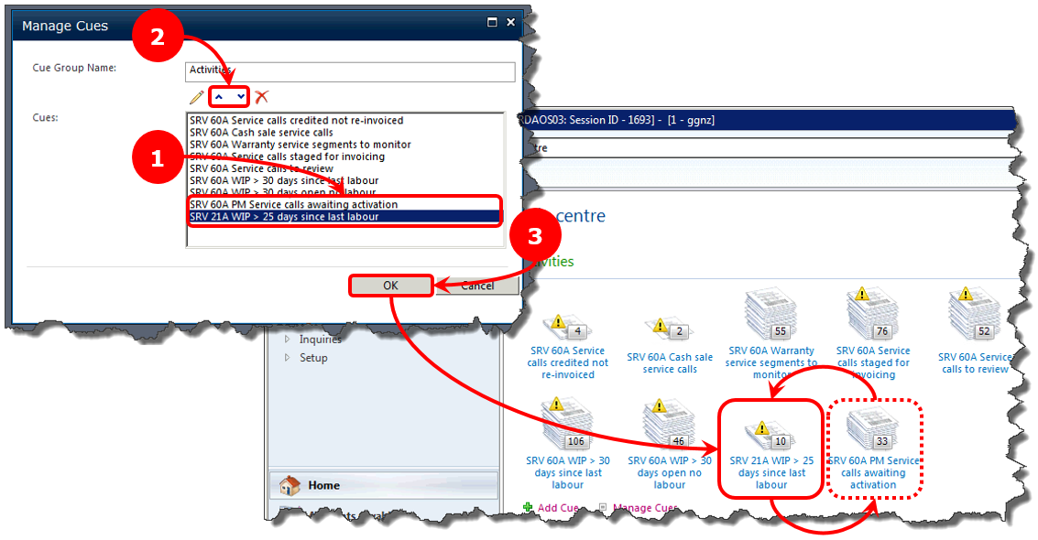

**Step 3B: Remove a cue**

1: Select the cue you want to remove.

2: Select the red ‘x’ icon.

3: The home page will re-appear; your selected cue will no longer be shown.

